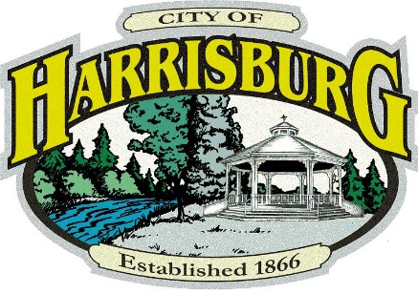

PUBLIC EVENT PERMIT

PROPOSED EVENT – MICHAEL BRYSON FOUNDATION
MARATHON SHUFFLE – Permit #2024-2

Citizens who would like to make comments or have concerns about this event must contact the City Recorder at lross@ci.harrisburg.or.us, or the City Administrator, meldridge@ci.harrisburg.or.us, or contact us via phone at 541-995-6655. by July 27, 2024. Concerns shared could require alteration of the conditions noted below:

PROPOSED CONDITIONS OF APPROVAL
The following conditions of approval are proposed to apply to the Michael Bryson Foundation Marathon Shuffle 5K Public Event.
- Consistency with Plans – The public event shall comply with the dates, plans and narrative in the application, except as modified by this approval.
- Non-City Property Consent – The applicant is responsible for obtaining consent to use any property not owned and controlled by the City. This shall include property belonging to the Harrisburg School District, as well as the segment of Kramer (Sommerville Loop) that is currently owned by Linn County.
  - Condition of Approval: The City must be provided with a copy of the approved permit from Linn County.
- Race Routes – Shall be well-marked. Runners should remain on pedestrian and bike right-of-way areas. Event organizers should post signs that an event is being held and for drivers to exhibit caution as they share the road with runners.
  - Condition of Approval: The current route as marked in the application must be updated to compensate for the closure of 6th St. between Smith St. & Kesling St. The Applicant shall provide the revised route no later than July 24, 2024.
- Street Crossings - The applicant shall provide Race Monitors at all street crossings on the race route. The purpose of the Monitors is to protect race participants; the public and vehicle traffic, and prevent conflict to the greatest extent practical. Monitors shall be trained in their ability to stop traffic if needed.
- Notifications to Participants - Runners shall be cautioned prior to each race that they are sharing the roadway with live vehicle traffic, and other pedestrians. Disabled pedestrians shall be given the right-of-way. Runners shall not run in groups that are larger than the right-of-way that is available.
- Compliance with Other Agency Permits – The applicant shall comply with all permits, licenses, etc. and any conditions related thereto obtained for this Public Event.
- Sanitary Facilities – Sanitary facilities are required. The applicant can arrange to use the facilities at the Grade School or may pay to have a sanitary unit brought to the race start/end point.
  - Condition of Approval: Applicant must make arrangements to use the schools restrooms, or must bring in a porta-potty station for the event.
- Signage – The applicant must have signage that shows the route location. Stop Signs should be available if needed at the corner of LaSalle & 6th St., at 6th & Priceboro, and on LaSalle & 9th.
- Trash & Debris – The applicant shall be responsible to ensure any trash and debris is removed from the streets and any publicly owned land after the event.
- Amplified Noise – The applicant shall not allow to be played any amplified noise more than two hours ahead of the event, or two hours following.
- Dust – The applicant shall not do any activity that causes or creates unreasonable amounts of dust to travel from the event site to neighboring properties.
- Insurance – The applicant must provide a Certificate of Liability Insurance Coverage with the City of Harrisburg listed as Additional Insured, in the amount of $1M per occurrence, and $2M in aggregate. Proof of Insurance must be provided by July 24, 2024.
  - Condition of Approval: Applicant must provide a new Certificate of Liability Insurance with the City of Harrisburg listed as Additional Insured, in the amount of $1M per occurrence, and $2M in aggregate by July 24, 2024.

